7.3.6 Editors - 3D View - Sidebar - Tool Tab - Sculpt Mode
Detailed table of content 1
Tools Tab in Sculpt Mode 5
Sculpt Mode - Brush Panel 5
Brush Panel 5
Sculpt Mode - Texture Panel 10
Sculpt Mode - Stroke Panel 16
Stroke Panel with Stroke method Space 16
Stroke Panel with Stroke method Curve 17
Stroke Panel with Stroke method Line 19
Stroke Panel with Stroke method Airbrush 20
Stroke Panel with Stroke method Drag dot 22
Stroke Panel with Stroke method dot 23
Sculpt Mode - Falloff Panel 24
Selecting Points 24
Adding Points 24
Navigation elements 24
Sculpt Mode - Dyntopo Panel 25
Dyntopo Panel 25
Sculpt Mode - Symmetry / Lock Panel 27
Mirror 28
Lock 28
Tiling 28
Radial 28
Tile Offset 28
Feather 28
Sculpt Mode - Options Panel 29
Threaded Sculpt 29
Fast Navigate 29
Use Deform only 29
Show Diffuse Color 29
Show Mask 29
Unified Settings 29
Gravity 29

Detailed table of content

Detailed table of content
Detailed table of content 1
Tools Tab in Sculpt Mode 5
Sculpt Mode - Brush Panel 5
Brush Panel 5
Browse Brush 5
Radius 6
Strength 6
Direction Add / Subtract 6
Normal Radius 6
Autosmooth 6
Plane Offset 6
Plane Trim 7
Distance 7
Height 7
Persistent 7
Set Persistent Base 7
Magnify 7
Pinch 7
Grab active Vertex 7
Deformation 8
Volume Preservation 8
Rake 8
Pose Origin Offset 8
Mask Tool 8
Options 8
Topology Automasking 8
Accumulate 8
Radius Unit 8
Sculpt Plane 9
Original Normal 9
Original Plane 9
Front Faces Only 9
2D Falloff 9
Sculpt Mode - Texture Panel 10
Browse Texture to be linked 10
Adding a texture 10
Texture Edit box 11
Brush Mapping 11
Brush Mapping with mapping method View Plane and Area Plane 12
Angle edit box 12
Rake 12
Random 12
Random edit box 12
Offset 13
Size 13
Sample Bias 13
Brush Mapping with mapping method Tiled 13
Angle edit box 13
Offset 13
Size 13
Sample Bias 13
Brush Mapping with mapping method 3D 14
Offset 14
Size 14
Sample Bias 14
Brush Mapping with mapping method Random 14
Angle edit box 15
Rake 15
Random 15
Random edit box 15
Offset 15
Size 15
Sample Bias 15
Brush Mapping with mapping method Stencil 15
Image Aspect 16
Angle edit box 16
Offset 16
Stencil Texture Controls 16
Sculpt Mode - Stroke Panel 16
Stroke Panel with Stroke method Space 16
Spacing Edit Box 17
Adjust Strength for Spacing 17
Jitter Edit Box 17
Input Samples Edit Box 17
Smooth Stroke 17
Smooth Stroke Radius Edit Box 17
Smooth Stroke Factor Edit Box 17
Stroke Panel with Stroke method Curve 17
Spacing Edit Box 18
Paint Curve edit box 18
Draw Curve Button 19
Adjust Strength for Spacing 19
Jitter Edit Box 19
Input Samples Edit Box 19
Stroke Panel with Stroke method Line 19
Spacing Edit Box 20
Adjust Strength for Spacing 20
Jitter Edit Box 20
Input Samples Edit Box 20
Stroke Panel with Stroke method Airbrush 20
Rate Edit Box 21
Jitter Edit Box 21
Input Samples Edit Box 21
Smooth Stroke 21
Smooth Stroke Radius Edit Box 21
Smooth Stroke Factor Edit Box 21
Stroke Panel with Stroke method Anchored 22
Edge to Edge 22
Input Samples Edit Box 22
Stroke Panel with Stroke method Drag dot 22
Input Samples Edit Box 23
Stroke Panel with Stroke method dot 23
Jitter Edit Box 23
Input Samples Edit Box 23
Smooth Stroke 23
Smooth Stroke Radius Edit Box 23
Smooth Stroke Factor Edit Box 23
Sculpt Mode - Falloff Panel 24
Selecting Points 24
Adding Points 24
Navigation elements 24
Zoom in and out 24
Tools 24
Reset View 24
Vector Handle 24
Auto Handle 25
Auto Clamped Handle 25
Reset Curve 25
Use Clipping 25
Delete Points 25
Curve Presets 25
Sculpt Mode - Dyntopo Panel 25
Dyntopo Panel 25
Resolution 26
Sample detail size picker 26
Refine method 26
Subdivide Collapse 26
Collapse Edges 26
Subdivide Edges 26
Detail Type Method 26
Relative Detail 26
Brush Detail 26
Constant Detail 26
Manual Detail 27
Smooth shading 27
Direction 27
Symmetrize 27
Optimize 27
Detail Flood Fill 27
Sculpt Mode - Symmetry / Lock Panel 27
Mirror 28
Lock 28
Tiling 28
Radial 28
Tile Offset 28
Feather 28
Sculpt Mode - Options Panel 29
Threaded Sculpt 29
Fast Navigate 29
Use Deform only 29
Show Diffuse Color 29
Show Mask 29
Unified Settings 29
Size 29
Strength 29
Color 29
Gravity 29
Factor 29
Orientation 30

Tools Tab in Sculpt Mode

Sculpting is a process to deform the geometry by using a brush. Mesh objects can be sculpted. And Grease Pencil can be sculpted. In this chapter we handle the mesh tools. Grease Pencil has its own chapter.

In Sculpt Mode you will mainly find settings for the different brushes. General settings. And brush specific settings. This settings can be found in different panels. The different brushes have different options and settings, dependant of which brush is selected. This brush specific options and settings are explained in the tool shelf chapter. Here we just cover the general panels with options and settings that exists for (nearly) all brushes.

The Sculpt Mode just exists for Mesh objects.

Sculpt Mode - Brush Panel
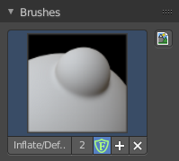
The Brush Panel contains a image browser to display the different Sculpt Brushes. Usually you have just one icon when you choose a brush from the tool shelf. But you can create your own brushes, based at the current chosen brush type. They save with the blend file when fake user is ticked.

Browse Brush
The big image at the top is a dropdown box where you can see the currently active brush. The file browser just shows the current active brush. Which gets chosen in the 3d view in the tool shelf. You can duplicate this brush, and modify it to your needs.
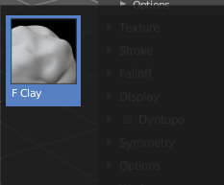
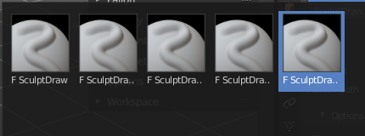
When you have added a few more brushes then the dropdown box may be more than full. You will see some little white arrows then. Either in the top left or in the bottom right corner. They indicate that some brushes are hidden before or after the current display.
To scroll to this hidden content use the mouse wheel, or the arrow up and down buttons at the keyboard.

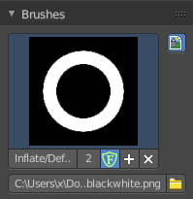
Custom Icon
The button at the right allows you to load a custom icon for your brush. It reveals a file browser below the image browser.

The edit box below the Image shows you the name of the current active brush.
The number right of it, in this case 2, indicates how much number of users ( internally ) this brush uses. This means that this data block (the brush) shares currently settings with at least one other object. Most probably the parent brush where we have created it from. Click at the value to make this brush a single user. The button will vanish then.
F set the brush to have a fake user. Zero user data-blocks are normally not saved. But sometimes you want to force the data to be kept even when the data block has no user.
The + button allows you to add a new pencil with the current settings. Note that the brushes are NOT saved when you close Bforartists. You can save them into the current blend file. Or you can save the startup file. But be careful here. This saves everything else of the current state of Bforartists too.
The X button deletes the brush as the active one. It does NOT delete it from the brushes list.

Sculpt Mode - Brush Settings Panel
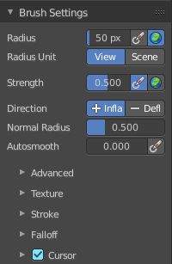
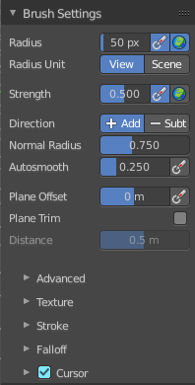
The Brush Settings Panel contains the Brush settings. The content differs, dependant of which brush you have chosen.

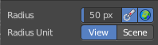
Radius
The Radius edit box allows you to adjust the radius of the brush. When the Lock symbol at the front is ticked, then the pencil keeps its size relative to the object when zooming in and out.

Size Pressure
The first button behind the edit box enables tablet pressure sensitivity for radius.

Use Unified Radius
The second button behind the edit box enables global radius size. Any modification at the radius will also modify the radius value for other paint tools.

Radius Unit
Display the radius value in view units or in scene units. View units are by default in pixels, scene units in meters.

Strength
The Strength edit box allows you to adjust the strength of the brush. When the Lock symbol at the front is ticked, then the pencil keeps its strength relative to the object when zooming in and out. The button behind the edit box enables tablet pressure sensitivity for strength.

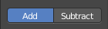
Direction Add / Subtract
Add means the stroke adds to the geometry. Subtract means the stroke subtracts from the geometry.

Normal Radius
The ratio between the brush radius and the radius that is going to be used to sample the normal

Autosmooth
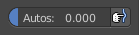
The autosmooth edit box allows you to adjust the amout of smoothing that gets automatically applied to each stroke. The button behind the edit box enables tablet pressure sensitivity for autosmooth.

Plane Offset
Clay brush setting. Adjust the plane on which the brush acts towards or away from the objects surface. Sculpting with the Clay brush happens in a plane defined by the view you are in and the first vertices hit by the brush.

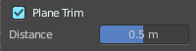
Plane Trim
Clay brush setting. Enable Plane Trim. Sculpting with the Clay brush happens in a plane defined by the view you are in and the first vertices hit by the brush. The trim distance defines a limit above which vertices are not affected by the brush.

Distance
Here you can adjust the plane trim distance.

Height
Layer brush setting. The height that can be affected by the layer brush.

Persistent
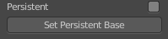
Layer brush setting. Sculpt on a persistent layer of the mesh.

Set Persistent Base
This button resets the base so that you can add another layer.

Magnify
Blob Brush setting. The Crease Brush Pinch Factor.

Pinch
Crease Brush setting. The Crease Brush Pinch Factor.

Grab active Vertex
Grab brush setting. Apply the maximum grab strength to the active vertex instead of the cursor position.

Deformation
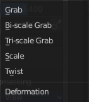
Elastic Deform brush setting. The deformation type that is used for the brush.

Volume Preservation
Elastic Deform brush setting. Poisson ratio for elastic deform. The higher the value is the more the volume is kept. But leads to more bulging.

Rake
Snake Hook brush setting. How much grab will follow cursor rotation.

Pose Origin Offset
Pose Brush setting. Offset of the pose origin in relation to the brush radius.

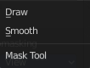
Mask Tool
Draw or smooth the current mask.

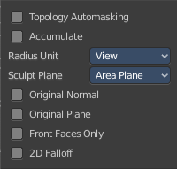
Options
In the options you can find the not so often used settings. They differ from brush to brush. Have a look at the tooltips.

Topology Automasking
Affect only vertices that are connected to the current active vertex under the brush.

Accumulate
Accumulate stroke daubts on top of each other.

Radius Unit
Here you can adjust the unit in which the brush works. Relative to the view, or relative to the scene. Relative to the view means you can zoom out and the brush becomes relatively bigger compared to the mesh. With scene you can zoom in and out, and the brush size stays the same relative to the mesh.

Sculpt Plane
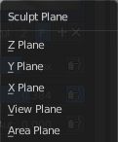
The sculpt plane defines how the sculpting is aligned. It is a dropdown box where you can choose different methods. By default the Area Plane gets used.

Original Normal
When ticked keep using normal of the surface where the stroke was initiated.

Original Plane
When ticked keep using plane origin of the surface where the stroke was initiated.

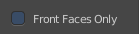
Front Faces Only
Front Faces only means that the stroke just affects the vertices that are pointing forwards to the camera.

2D Falloff
Apply the brush influence in 2d circle instead of a sphere.

Sculpt Mode - Texture Panel
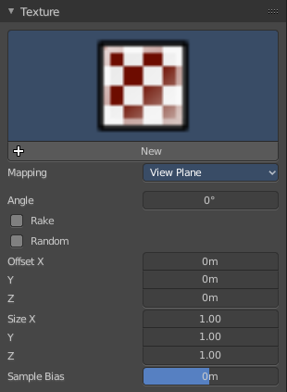
The Texture panel allows you to sculpt with textures. This allows you for example to grab a foto from some fish scales, and simply sculpt them into the surface of your object by using this image as a pencil. Or as a blueprint where you calk through ( Stencil method ).

Note that the following shots are made with Symmetry off and without Brush falloff. Since they disturbed.

Symmetry can be turned off a few panels deeper in the Symmetry panel:

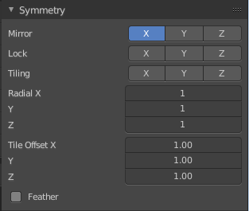

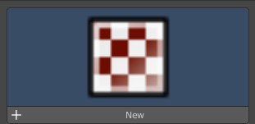
Browse Texture to be linked
The image at the top of the panel is a image browser. Here you can choose a texture that you can choose for sculpting then. You can also have more than one image loaded at once.

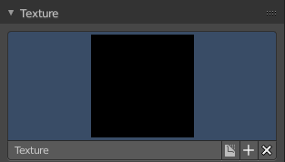
Adding a texture

The way to add the texture here is a bit more complicated. And not done with clicking at the New button.

First click at the New button below the image. This will create a new texture slot. This slot is still empty, it displays black.

We need to load the texture in this slot. This must be done in the Properties editor in the Textures tab.

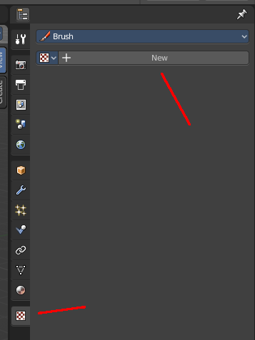
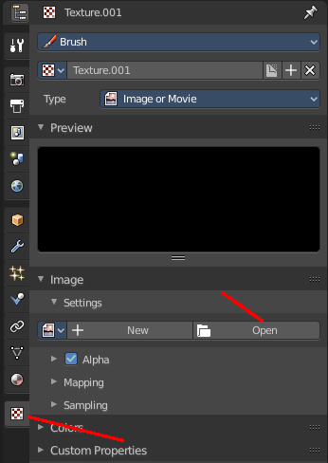
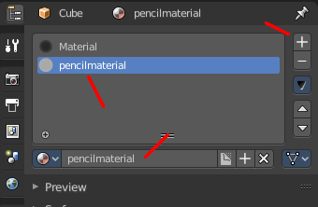
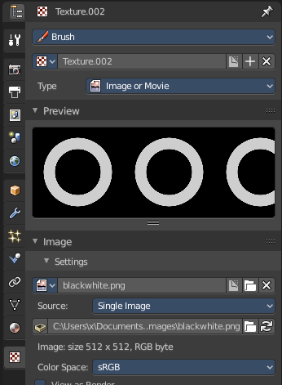

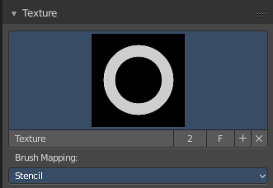
And when you switch back to the Tools tab, then the texture finally shows in the Texture panel in the Tool Shelf. And we can use it.

Texture Edit box
The Texture edit box is the edit box below the Image browser. When there's no image loaded then it displays the New button. When there's a image (or more) loaded, then you will see the name of the current texture.
The Fake User button turns this texture into a data block with a fake user. Means it will exists even when there is no data connected to it anymore.
The + Button adds another texture slot. Note that you will have to load a texture too, as explained above.
The X button deletes the texture slot.

Brush Mapping
Our texture can be mapped in different methods. The Brush mapping is a dropdown box where you can choose this different brush mapping methods.
The settings vary. So we will go through them by the different brush mapping methods.

Brush Mapping with mapping method View Plane and Area Plane
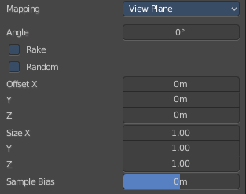
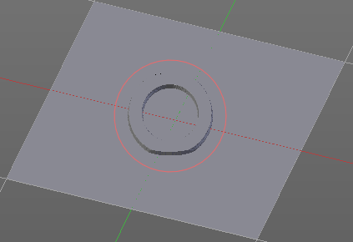
The brush mapping method View Plane maps the brush onto the surface of the object, calculating the mapping from the current view. The result may be distorted when the view does not align with the surface of the object.
The brush mapping method Area Plane maps the brush onto the surface of the object, calculating the mapping from the current view. The result is not distorted.

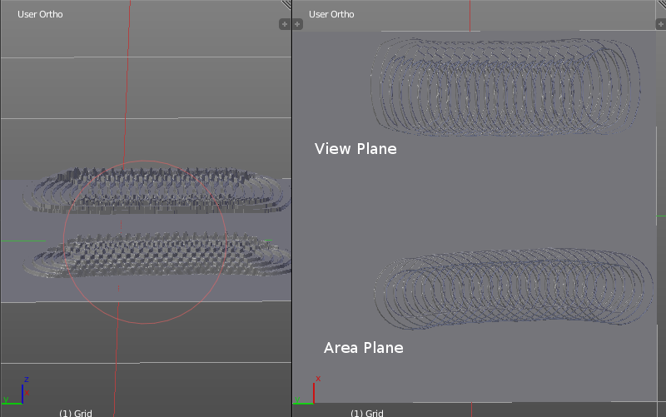
Angle edit box
Here you can adjust the angle of the brush.

Rake
The angle follows the direction of the brush stroke.

Random
The brush angle gets set random.

Random edit box
Becomes visible when you tick Random. Here you can adjust the maximum value of the random angle.

Offset
Fine tune the offset of the texture in the brush.

Size
Fine tune the size of the texture in the brush.

Sample Bias
Here you can add to or subtract from the amount that gets added by the brush texture.

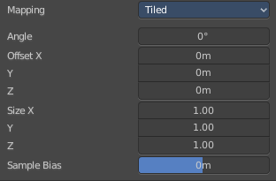
Brush Mapping with mapping method Tiled
The brush mapping method View Plane maps the brush onto the surface of the object, and tiles the pencil onto the surface. The mapping happens from the View plane. Means you get distortions when you sculpt from an angle.
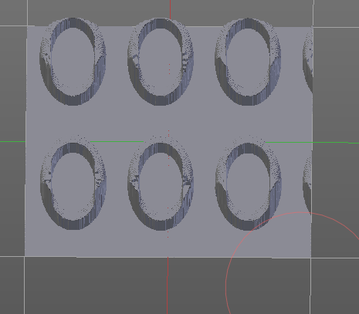

Angle edit box
Here you can adjust the angle of the brush.

Offset
Fine tune the offset of the texture in the brush.

Size
Fine tune the size of the texture in the brush.

Sample Bias
Here you can add to or subtract from the amount that gets added by the brush texture.

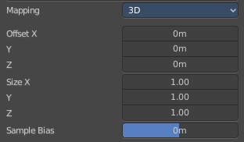
Brush Mapping with mapping method 3D
The brush mapping method View Plane and Area Plane sculpts where the pencil is. The method 3D sculpts at the initial position of the pencil, as long as you don't release the mouse. The mapping happens from the View plane. Means you get distortions when you sculpt from an angle.

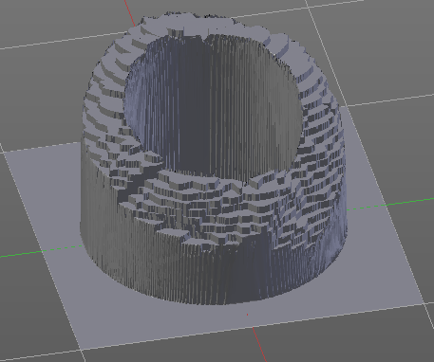
Offset
Fine tune the offset of the texture in the brush.

Size
Fine tune the size of the texture in the brush.

Sample Bias
Here you can add to or subtract from the amount that gets added by the brush texture.

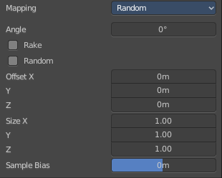
Brush Mapping with mapping method Random
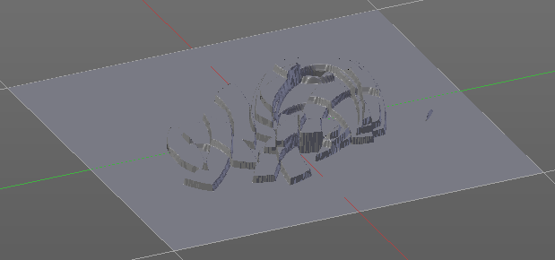
The brush mapping method Random randomizes the texture position of the pencil texture. And so it sculpts random fragments of the pencil.

Angle edit box
Here you can adjust the angle of the brush.

Rake
The angle follows the direction of the brush stroke.

Random
The brush angle gets set random.

Random edit box
Becomes visible when you tick Random. Here you can adjust the maximum value of the random angle.

Offset
Fine tune the offset of the texture in the brush.

Size
Fine tune the size of the texture in the brush.

Sample Bias
Here you can add to or subtract from the amount that gets added by the brush texture.

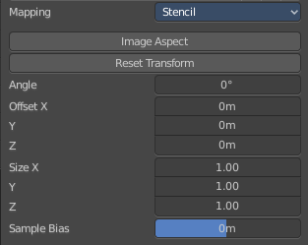
Brush Mapping with mapping method Stencil
The former methods uses the textures for the brush. The method Stencil works different. You have your texture displayed in the workspace above the object, and you paint this texture onto your object with your pencil strokes.
Note that the texture in the 3d space is just visible when you are with the mouse over the viewport.

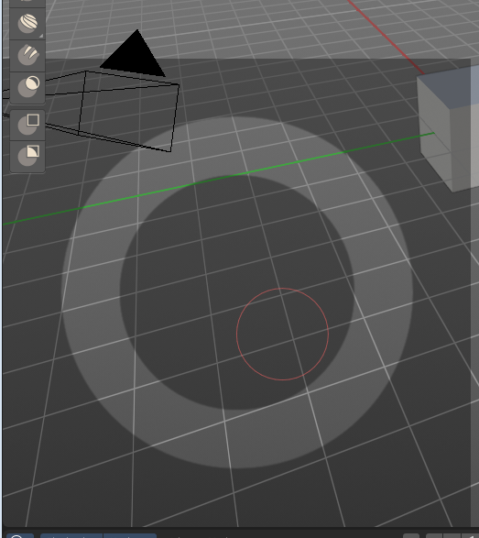
Image Aspect
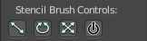
Adjust the stencil size to fit to the image aspect ratio.

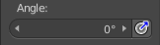
Angle edit box
Here you can adjust the angle of the brush. The button at the end allows you to set the radius by dragging the mouse. This should be done in the viewport and with the hotkey. This button is just a visible reminder.

Offset
Fine tune the offset of the texture in the brush.

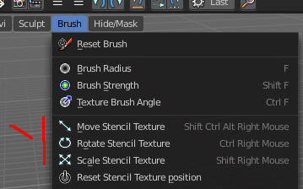

Stencil Texture Controls
You can find the controls to modify the position, rotation and scale of the stencil texture in the Brush menu in the 3D view. This happens by Hotkeys.

Sculpt Mode - Stroke Panel
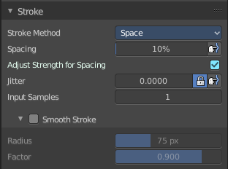
The Stroke panel contains settings to influence the behaviour of the brush stroke. There are various stroke methods available. We will go through them one by one.

Stroke Panel with Stroke method Space
This is the default Stroke method. The sculpt stroke gets added continuously with given settings.
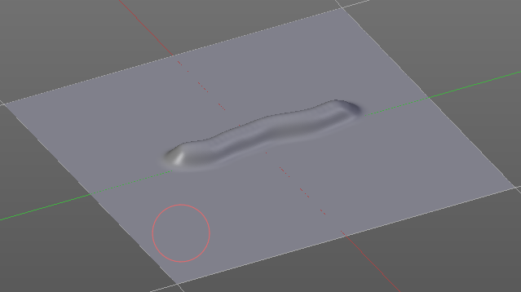

Spacing Edit Box
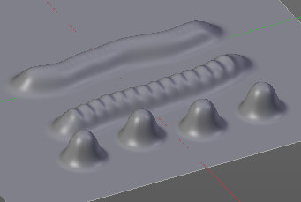
The sculpt drawing happens by mapping the pencil onto the mouse position. And when you move the mouse then the next mapping happens. Here you can adjust the spacing after what mouse movement the next mapping should happen. The lower the value, the lower the distance between the single dots.
The icon behind the edit box enables tablet pressure sensitivity for tablets.

Adjust Strength for Spacing
Automatically adjust the strength to give consistent results for different spacings.

Jitter Edit Box
Here you can add Jitter to the brush while painting.
The icon in front of the edit box toggles between jittering in screen space and relative to brush size.
The icon behind the edit box enables tablet pressure sensitivity for tablets.

Input Samples Edit Box
Average multiple input samples together to smooth the brush stroke.

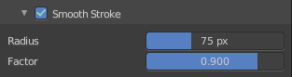
Smooth Stroke
When activated then the brush lags behind the mouse position, and produces a much smoother stroke by that. It is a subpanel with two settings.

Smooth Stroke Radius Edit Box
Here you can adjust the radius of the smoothing.

Smooth Stroke Factor Edit Box
Here you can adjust the factor of the smoothing.

Stroke Panel with Stroke method Curve
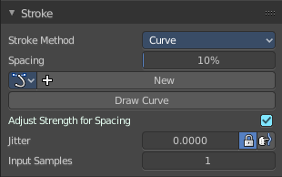
The Stroke method curve doesn't simply influence the way how the stroke is painted.
It is a special method. First you draw a curve object by holding down ctrl and clicking with left mouse button. Then you tweak the curve. You can click at the curve point, and drag out handlers to make the curve points smoooth.
Then you hit the Draw Curve button. And the curve gets sculpted.

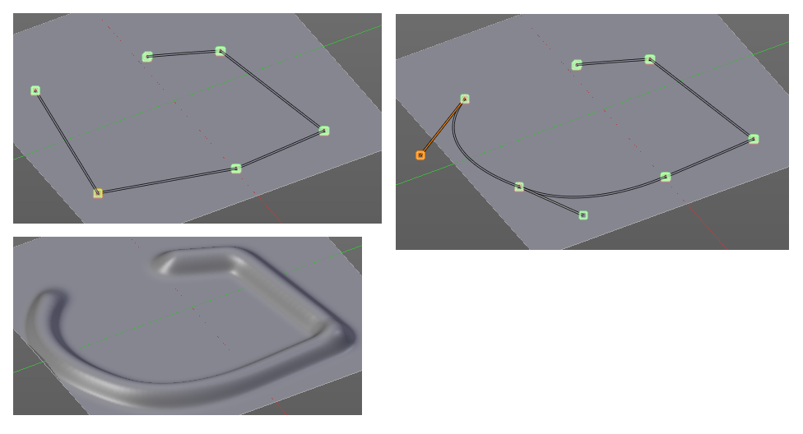

Spacing Edit Box
The sculpt drawing happens by mapping the pencil onto the mouse position. And when you move the mouse then the next mapping happens. Here you can adjust the spacing after what mouse movement the next mapping should happen. The lower the value, the lower the distance between the single dots.
The icon behind the edit box enables tablet pressure sensitivity for tablets.

Paint Curve edit box
Here you set the active curve.
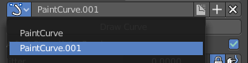
The first element is a dropdown box where you will find your curves objects. You can have more than one.
The second element is the edit box that displays the active curve.
Fake User set the brush to have a fake user. Zero user data-blocks are normally not saved. But sometimes you want to force the data to be kept even when the data block has no user.
The + button allows you to add a new pencil with the current settings. Note that the brushes are NOT saved when you close Bforartists. You can save them into the current blend file. Or you can save the startup file. But be careful here. This saves everything else of the current state of Bforartists too.
The X button deletes the brush as the active one. It does NOT delete it from the brushes list.

Draw Curve Button
A click at it to turns the curve into a sculpt stroke.

Adjust Strength for Spacing
Automatically adjust the strength to give consistent results for different spacings.

Jitter Edit Box
Here you can add Jitter to the brush while painting.
The icon in front of the edit box toggles between jittering in screen space and relative to brush size.
The icon behind the edit box enables tablet pressure sensitivity for tablets.

Input Samples Edit Box
Average multiple input samples together to smooth the brush stroke.

Stroke Panel with Stroke method Line
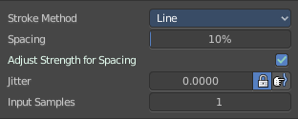
With Stroke method line you draw a line between a starting point and a endpoint. And when you release the mouse then the line gets sculpted.

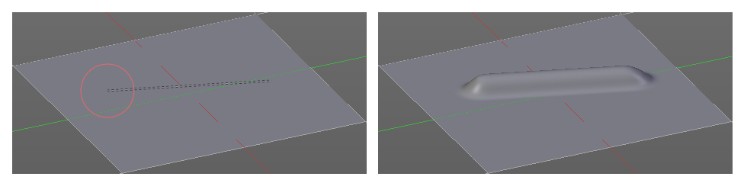

Spacing Edit Box
The sculpt drawing happens by mapping the pencil onto the mouse happens. Here you can adjust the spacing after what mouse movement the next mapping should happen. The lower the value, the lower the distance between the single dots.
The icon behind the edit box enables tablet pressure sensitivity for tablets.

Adjust Strength for Spacing
Automatically adjust the strength to give consistent results for different spacings.

Jitter Edit Box
Here you can add Jitter to the brush while painting.
The icon in front of the edit box toggles between jittering in screen space and relative to brush size.
The icon behind the edit box enables tablet pressure sensitivity for tablets.

Input Samples Edit Box
Average multiple input samples together to smooth the brush stroke.

Stroke Panel with Stroke method Airbrush
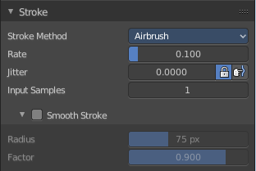
The sculpt stroke acts like an airbrush pencil. The dots gets placed randomly.
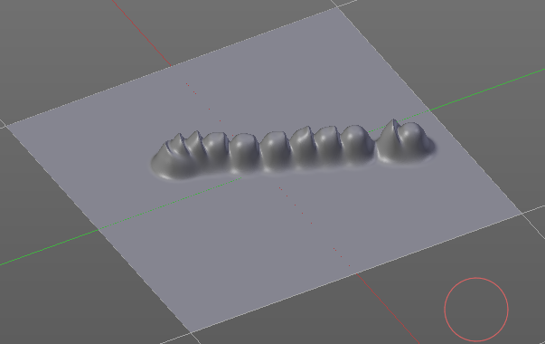

Rate Edit Box
Here you can define the rate of the drawing.

Jitter Edit Box
Here you can add Jitter to the brush while painting.
The icon in front of the edit box toggles between jittering in screen space and relative to brush size.
The icon behind the edit box enables tablet pressure sensitivity for tablets.

Input Samples Edit Box
Average multiple input samples together to smooth the brush stroke.

Smooth Stroke
When activated then the brush lags behind the mouse position, and produces a much smoother stroke by that. Smooth stroke has two settings.

Smooth Stroke Radius Edit Box
Here you can adjust the radius of the smoothing.

Smooth Stroke Factor Edit Box
Is just active when Smooth Stroke is activated. Here you can adjust the factor of the smoothing.

Stroke Panel with Stroke method Anchored
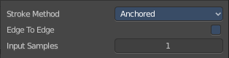
Click and drag to place a dot and to scale it.

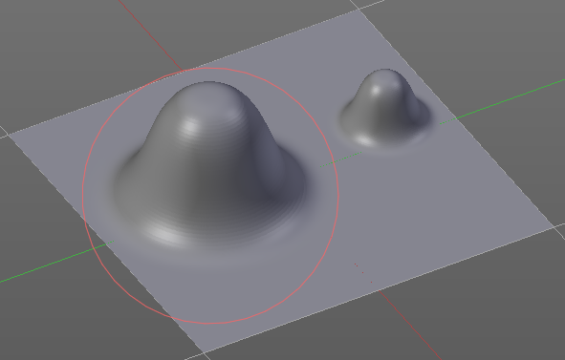

Edge to Edge
Without Edge to Edge the scaling happens from the center of the brush. With edge to edge the scaling happesn from the edge of the brush.

Input Samples Edit Box
Average multiple input samples together to smooth the brush stroke.

Stroke Panel with Stroke method Drag dot
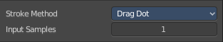
Click and drag to place a dot.

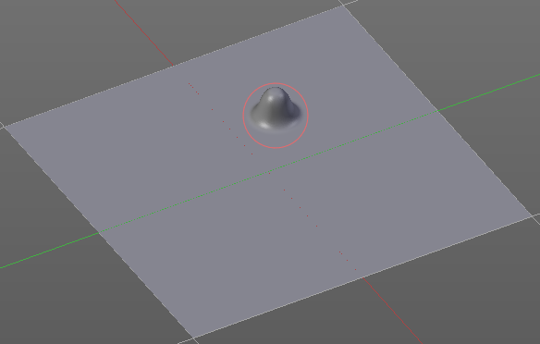

Input Samples Edit Box
Average multiple input samples together to smooth the brush stroke.

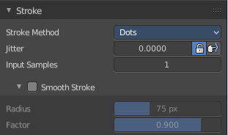
Stroke Panel with Stroke method dot
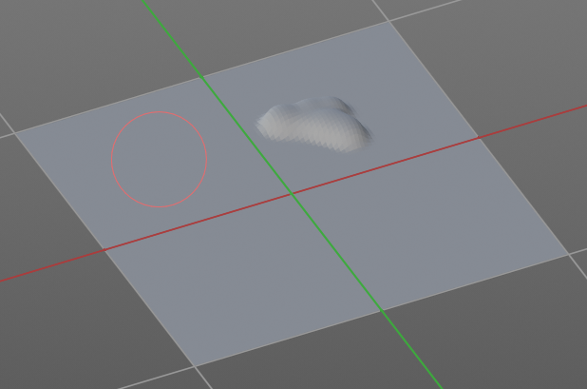

Jitter Edit Box
Here you can add Jitter to the brush while painting.
The icon in front of the edit box toggles between jittering in screen space and relative to brush size.
The icon behind the edit box enables tablet pressure sensitivity for tablets.

Input Samples Edit Box
Average multiple input samples together to smooth the brush stroke.

Smooth Stroke
When activated then the brush lags behind the mouse position, and produces a much smoother stroke by that. Smooth stroke has two settings.

Smooth Stroke Radius Edit Box
Here you can adjust the radius of the smoothing.

Smooth Stroke Factor Edit Box
Here you can adjust the factor of the smoothing.

Sculpt Mode - Falloff Panel
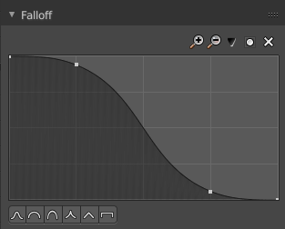
The Falloff panel allows you to define different fallofs methods for the border of the brush.


Selecting Points
You can select curve points. This reveals two edit boxes for the x and y coordinate of this point.
Selected points can be moved around. Left click at them, hold the mouse button down and move them to a new location.


Adding Points
You can add new curve points by simply left clicking at the curve. Move the mouse to position them where you need it.

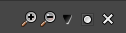
Navigation elements
The navigation elements at the top are described from left to right.

Zoom in and out
The two buttons with the magnifying glass at it zooms in and out in the curve window.

Tools
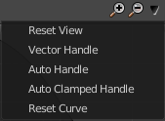
Tools is a menu where you can find some cuve related tools.

Reset View
Resets the curve windows zoom.

Vector Handle
Set handle type to Vector.

Auto Handle
Set handle type to Auto.

Auto Clamped Handle
Set handle type to Auto Clamped.

Reset Curve
Resets the curve to the initial shape.


Use Clipping
Clipping options. Here you can set up clipping for the stroke. The blue button at the top turns clipping on or off.

Delete Points
Deletes the selected curve point.


Curve Presets
Here you can find some predefined curve presets.

Sculpt Mode - Dyntopo Panel

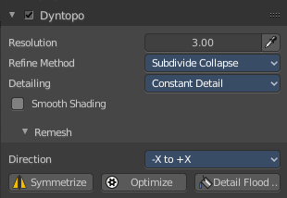
Dyntopo Panel
Dyntopo stands for Dynamic Topology Sculpting.
Without dyntopo you just deform the existing geometry. With Dyntopo geometry gets subdivided when needed. This makes it possible to sculpt complex shapes out of a block.
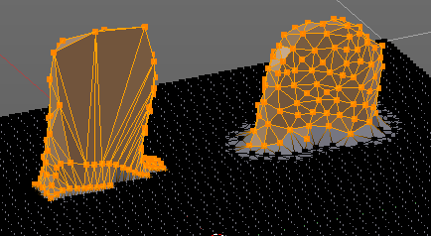
Left without Dyntopo, right with Dyntopo.
Note that some brushes does not work with Dyntopo. They are Grab brush, Rotate brush, Thumb brush, Layer brush, Smooth brush (including alt-key smoothing with a different brush) and Mask brush.
The topology will also not be updated if the stroke mode is Anchored or Drag Dot.

Resolution
The Resolution defines how fine the subdivision will be.
The edit box below does the same. But with a slider, and without visible feedback in form of a widget.

Sample detail size picker
This pipette allows you to pick the current resolution from a mesh.

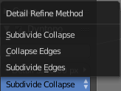
Refine method
Here you can define the Detail refine method.

Subdivide Collapse
Both methods in one. Subdivide long edges to add mesh detail where needed. And collapse short edges to remove mesh detail where possible.

Collapse Edges
Collapse short edges to remove mesh detail where possible.

Subdivide Edges
Subdivide long edges to add mesh detail where needed.

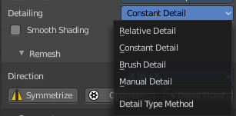
Detail Type Method
Here you can define the Detail Type method.

Relative Detail
Mesh Detail is relative to brush size and detail size

Brush Detail
Mesh Detail is relative to brush radius.

Constant Detail
Mesh detail is constant in object space according to detail size.

Manual Detail
Mesh detail does not change on each stroke. But just on flood fill

Smooth shading
Show faces in smooth shading instead of flat shading.

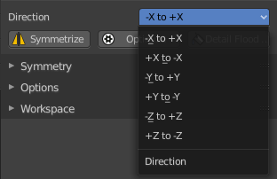
Direction
Source and Destination for Symmetrize operator. This has to do with the symmetrize button below.

Symmetrize
Symmetrize the topology modifications.

Optimize
Recalculate the sculpt BVH to improve performance.

Detail Flood Fill
Flood fill the mesh with the selected detail setting.

Sculpt Mode - Symmetry / Lock Panel
The Symmetry Lock panel contains tools around symmetry and lock features. Here you can turn on or off mirroring along axis, etc.

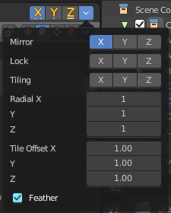
Mirror
Mirror sculpt along activated axis. By default the mirroring is activated around X axis.
The same buttons plus the whole Symmetry Lock Panel as a dropdown menu can also be found in the tool settings bar as icon buttons. This allows quicker access and better visual control which mirror axis is currently active.

Lock
Disallow vertices movement in locked axis direction.

Tiling
Produces a mesh that is tilable in the activated directions.

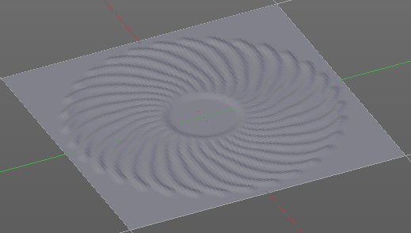
Radial
Adjust the repeatings across some axis. For example, when you change Z to 32, then you can draw 32 segments simultaneously around the Z axis instead of just one, distributed around the Z axis.

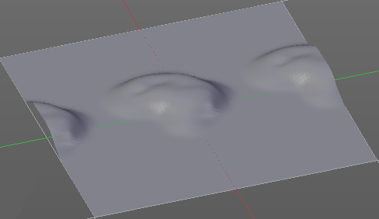
Tile Offset
Here you can adjust the offset of the tiling.

Feather
Reduce the strength of the brush where it overlaps symmetrical daubs.

Sculpt Mode - Options Panel
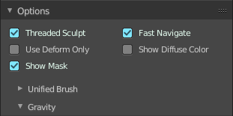

Threaded Sculpt
Use multiple CPU cores for sculpting.

Fast Navigate
For Multires, show Low Res mesh when navigating.

Use Deform only
Use only deformation modifiers ( The other constructive modifiers except multi-resolution gets temporary disabled)

Show Diffuse Color
Show the diffuse color of the object while sculpting.

Show Mask
Show mask as overlay on object.

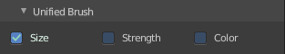
Unified Settings
A panel with the unified brush settings.

Size
Instead of per Brush radius, the radius is shared across brushes.

Strength
Instead of per Brush strength, the strength is shared across brushes.

Color
Instead of per Brush color, the color is shared across brushes.

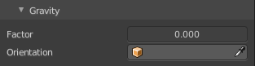
Gravity
A panel with the gravity settings. Here you can add gravity after each stroke.

Factor
The factor silder defines the amount.

Orientation
Here you define an object that gets used to determine the gravity from. The Z axis of this object gets used.

